Ewalt Volschenk

Week 3: practical

Deploying the VM
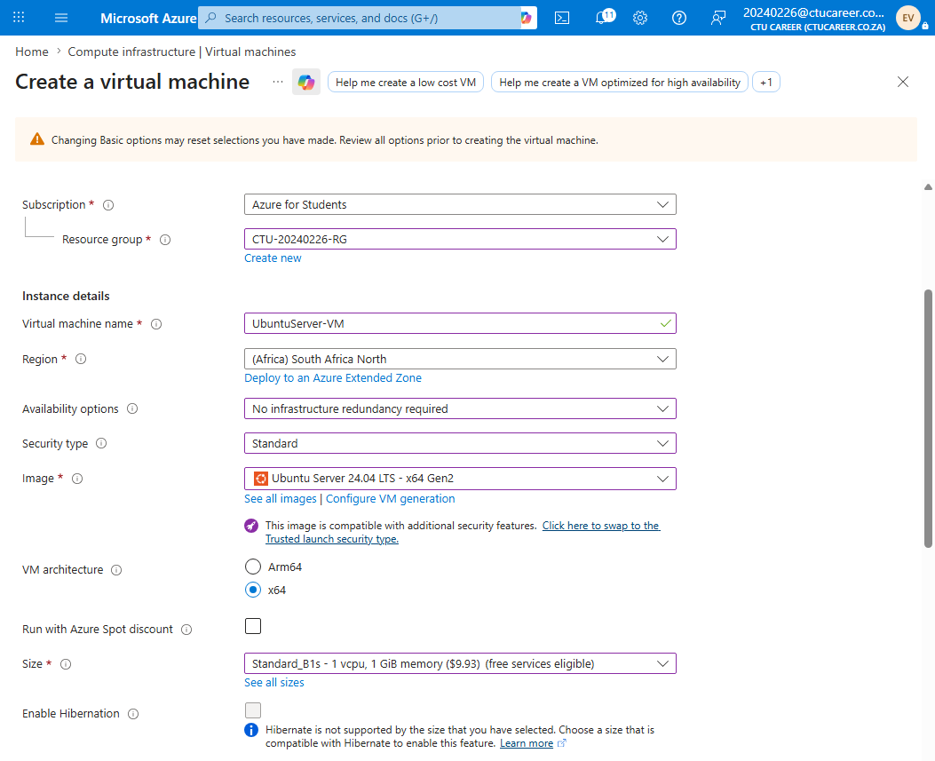
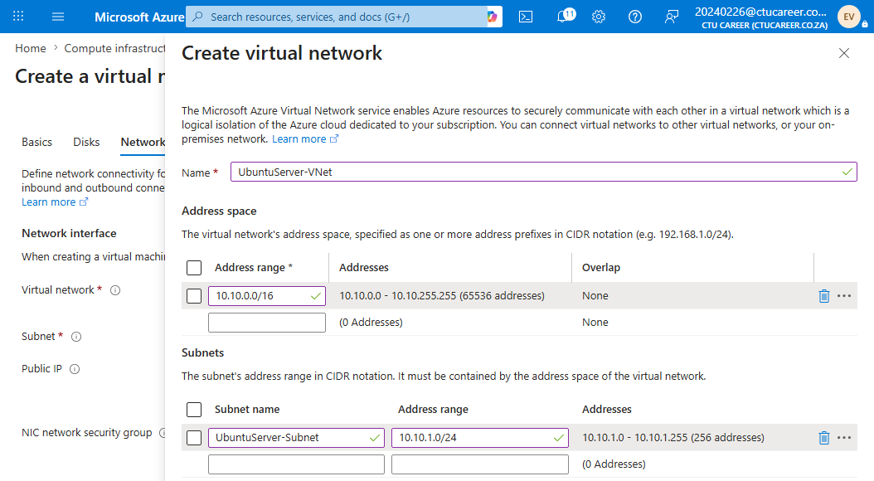
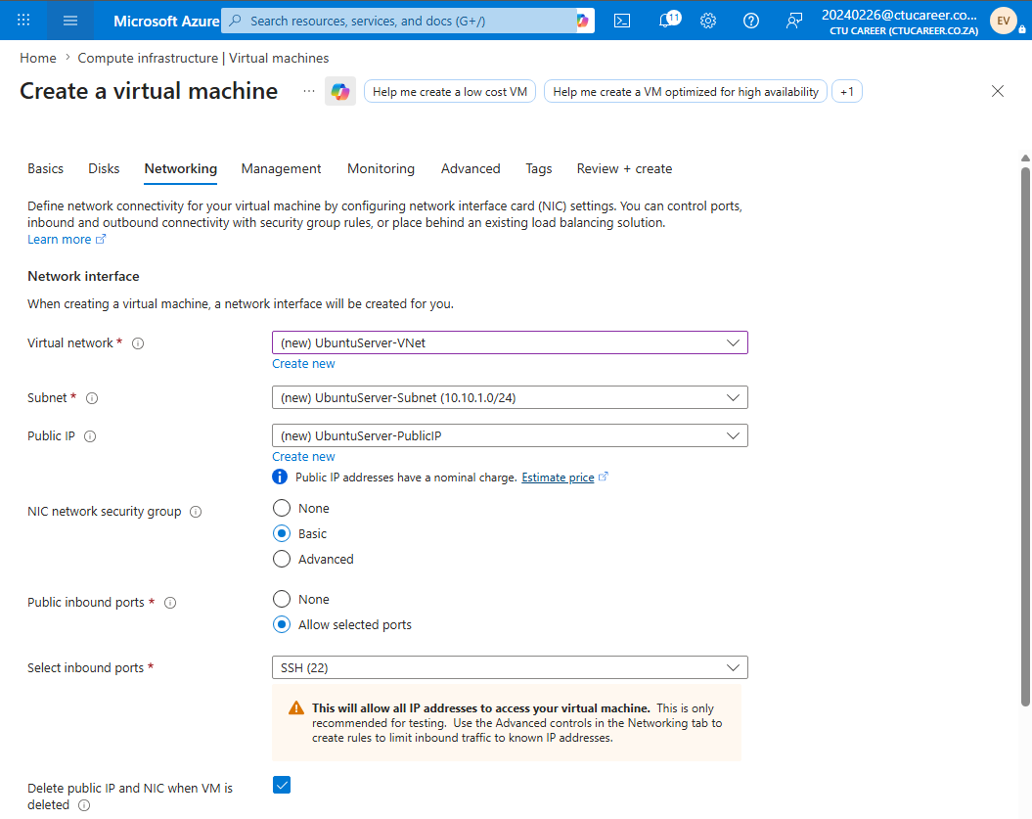
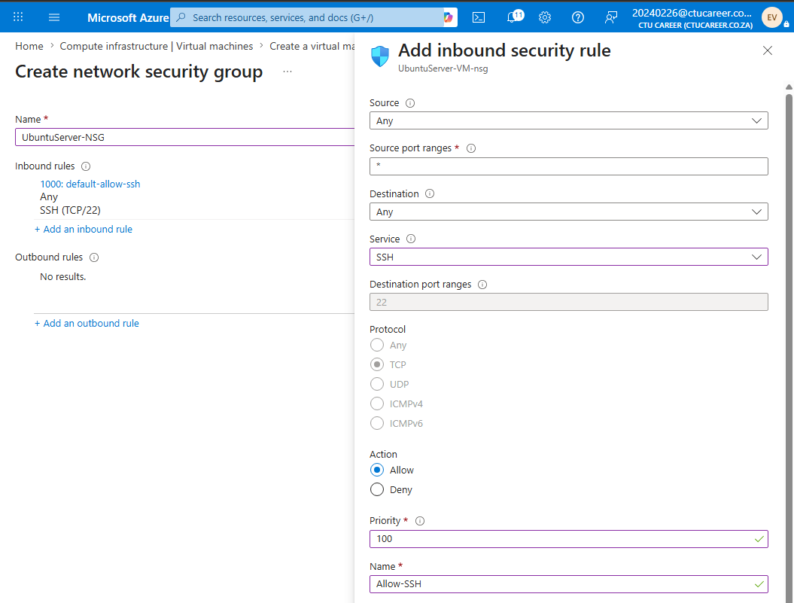
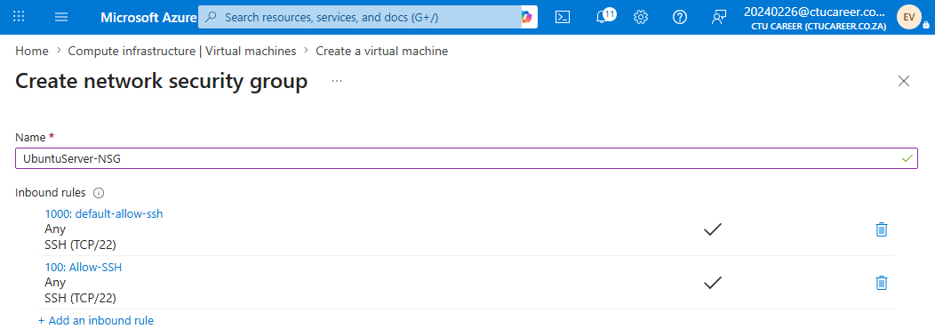
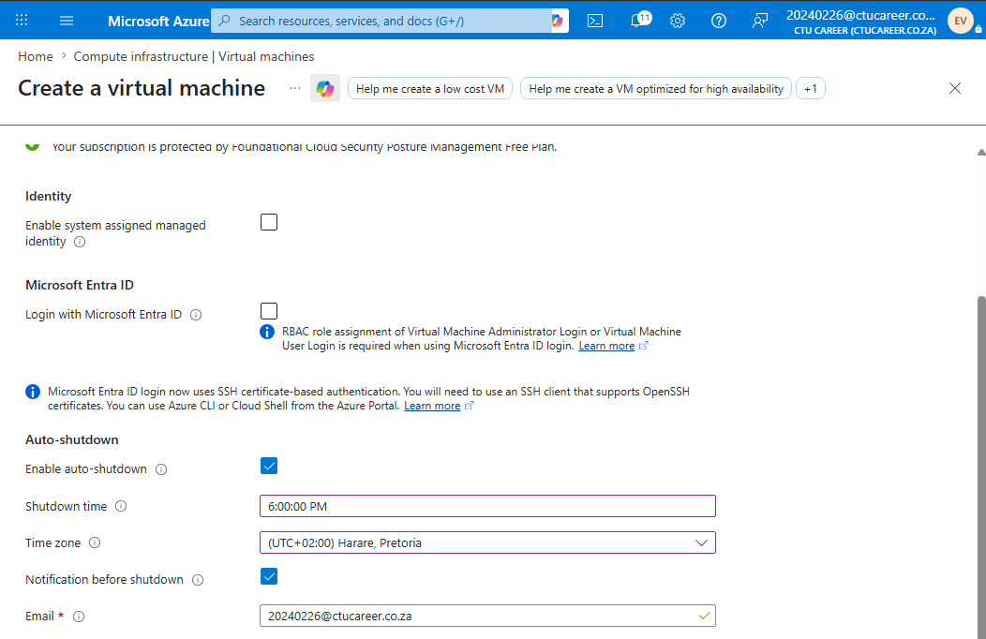

Documentation

VM Summary
Field | Value
VM Name | UbuntuServer-VM
Resource Group | CTU-20240226-RG
Region | South Africa North
VM Size | Standard_B1s
OS Image | Ubuntu Server 24.04 LTS
Authentication Method | SSH Public Key
Authentication Justification | I chose SSH key authentication over password login because it is significantly more secure as it eliminates the risk of brute-force password attacks.

Network Summary
Field | Value
VNet Name | UnuntuServer-VNet
VNet Address Space | 10.10.0.0/16
Subnet Name | UbuntuServer-Subnet
Subnet CIDR | 10.10.1.0/24
Public IP Name | UbuntuServer-PublicIP
Assignment | Static
Public IP Address | 102.133.234.70

NSG Rule
Rule Name | Direction | Protocol | Port | Source | Action
Allow-SSH | Inbound | TCP | 22 | Any | Allow

Auto-Shutdown
Field | Value
Auto-Shutdown Enabled | Yes
Shutdown Time | 6:00 PM
Time Zone | UTC+02:00 — Harare, Pretoria (South Africa Standard Time)
Justification | Auto-shutdown was configured to trigger at 18:00 daily because this VM is used exclusively during daytime hours.

Reflection
The only issue encountered was the availability of Ubuntu Server 22.04 LTS. It has been replaced with Ubuntu 24.04 LTS on the Azure market, thus I settled with using Ubuntu 24.04 LTS which is a more recent version of Ubuntu Server.

